|  |  |  |  |  |  |  |  |  |  |  |  |  |  |  |  |  |  |  |  |  |  |  |  |  |  |
| --- | --- | --- | --- | --- | --- | --- | --- | --- | --- | --- | --- | --- | --- | --- | --- | --- | --- | --- | --- | --- | --- | --- | --- | --- | --- |
| |  |  | | --- | --- | | For office use only | | | T1 | ________________ | | T2 | ________________ | | T3 | ________________ | | T4 | ________________ | | |  | | --- | | Team Control Number **51195** | |  | | Problem Chosen **A** | | |  |  | | --- | --- | | For office use only | | | F1 | ________________ | | F2 | ________________ | | F3 | ________________ | | F4 | ________________ | |

**2016 MCM/ICM Summary Sheet**  
(Your team's summary should be included as the first page of your electronic submission.)

## Summary

In order to determine the best strategy to keep the temperature of water in the bathtub even throughout the bathtub and maintain the water temperature as close to initial temperature as possible, the paper proposes two model. Model one is established to determine the hot water speed and hot water temperature, while model two is used to determine the best shape and size of the bathtub.

In model one, the authors firstly need to analyze the heat loss and heat absorption of water in the bathtub. Then based on the assumption of dynamic balance, the authors establish the dynamic balance model, that is, through the equality of heat loss and heat absorption, combined with the goal of not wasting too much water and the water temperature that human can tolerant , calculate the hot water speed and determine the best temperature of hot water. The result is to keep the water close to the initial temperature with 50℃ hot water and in order to save water, hot water speed is decided to be 0.00431(L/s).

In model two, the authors design 7 shapes of bathtub at first. Then, Genetic Algorithm is applied to find the most-water saving sizes for the seven shapes and the corresponding hot water speed. Finally, we compare the 7 optimums (hot water speed) of different shapes gained by GA, choose the shape and size corresponding to the minimum hot water speed as the best bathtub. The best shape of bathtub is the combination of cone and frustum of a prism (sitting shape), and the detailed shape and size can be seen in Table5 and figure5.

What’s more, the sensitivity analysis is performed. During sensitivity analysis, the significant parameters are found, including the size of the bathtub, the value of heat transfer coefficient. And through the sensitivity analysis on heat convection coefficient we can find that bubble affect the model’s result little.

Finally, the strengths and weaknesses are discussed. And the paper proposes two model promotions. The first one is to design the hot water control system，the other is to determine the best strategy to fill the empty bathtub.

**Key word:** Genetic Algorithm Dynamic Balance Control variates

Newton's law of cooling Fourier's Law

**The models for a hot bath**

## Contents

I. Introduction 3

1.1 Problem background 3

1.2 our work 3

II. Symbols, Definitions and Assumptions 4

2.1 Symbols and Definitions 4

2.2 General Assumptions 6

III. Model one: macroscopical dynamic balance model 6

3.1 Introdution 6

3.2 Assumption 7

3.3 Model establishment 7

3.4 Model solution 11

3.5 Model test 14

IV .Model two: Shape selection based on GA 15

4.1 Introduction 15

4.2 Design the patterns of bathtub 15

4.3 Determine the best shape of bathtub: Genetic Algorithm 17

4.4 Result and Analysis 20

V. Sensitivity analysis 22

5.1 Introduction 22

5.2 Overall sensitivity analysis on all system parameters 23

5.3 Sensitivity analysis on the shape of bathtub 23

5.4 Sensitivity analysis on human factor 25

5.5 Sensitivity analysis on heat transfer coefficient 25

VI. Bubble does not matter 26

6.1 What the bubble affects 26

6.2 Bubble does not matter 26

VII. Strengths and Weaknesses 27

7.1 Strengths 27

7.2 Weaknesses 27

VIII. Promotion of the Model 28

8.1 The design of water control device 28

8.2 The best strategy to fill the empty bathtub 29

IX .The non-technical position paper 30

X. References 31

XI. Appendix 31

## I. Introduction

### Problem background

Enjoying in a hot bath is a happy thing while people finish a stressful day of working. Keeping an appropriate temperature of the bathtub water is in favor of relaxing, eliminating fatigue and promoting metabolism. However, it’s difficult to keep an appropriate temperature of the bathtub water evenly, because the bathtub is a simple water containment vessel instead of a spa-style tub with a secondary heating system and circulating jets. Therefore, it’s very crucial to keep the temperature of the bathtub water even throughout the bathtub and as close as possible to the initial temperature without wasting too much water.

The requirements of the subject are to determine the best strategy the person in the bathtub can adopt to keep the temperature even throughout the bathtub and as close as possible to the initial temperature without wasting too much water. Thus there are three main sub-problems.

* Develop the temperature of the bathtub water in space and time, analyze how to keep the temperature even throughout the bathtub and as close as possible to the initial temperature without wasting too much water.
* Use our model to analyze the level to which your strategy depends upon the shape and volume of the tub, the shape/volume/temperature of the person in the bathtub, and the motions made by the person in the bathtub.
* Taking the person used a bubble bath additive while initially filling the bathtub into account to analyze how would affect the result of the model of the temperature of the bathtub water.

### 1.2 Our work

In this paper we determine the best strategy to keep the temperature of the water in the bathtub even and as close to the initial temperature as possible, determine the best shape and size of bathtub, and make sensitivity analysis and model promotion. In model one, we provide the strategy about hot water speed and the temperature of hot water that people in the bathtub can adopt. In model two, we determine the best shape and size of the bathtub. And in the section of sensitivity analysis, we make sensitivity analysis on all parameters and pick out the remarkable parameters. And the strengths and weakness of model is discussed. In the section of model promotion, we propose two applications of model.

## II．Symbols, Definitions and Assumptions

### 2.1 Symbols and Definitions

In this section, we will give some basic symbols and definitions used in the following pages for convenience.

Table1.Variable Definition

|  |  |
| --- | --- |
| Variable Symbols | Definition |
|  | The heat loss from the water to the air |
|  | The heat loss from the water to the man in the bathtub |
|  | The heat loss from the water to the bathtub |
|  | The heat absorption from the hot water |
| H | The height of the man |
| W | The weight of the man |
|  | The area of the man |
|  | The volume of the man |
|  | The radius of the head |
|  | The radius of the neck |
|  | The area of the head |
|  | The contracting area between the man and the bathtub |
|  | The contracting area between the man and the water |
|  | The volume of water in the bathtub |
|  | The volume of the bathtub |
|  | The contracting area between water and air |
|  | The contracting area between water and the bathtub |
|  | The contracting area between tub and the bathtub |
|  | The convection heat transfer coefficient between the water and air |
|  | The temperature of the water in the bathtub |
|  | The temperature of air |
|  | The heat flux between water and air |
|  | The convective heat transfer rate between the water and air |
| T | Time |
|  | The convection heat transfer coefficient between water and people |
|  | The temperature of the water in the bathtub |
|  | The temperature of people |
|  | The heat flux between water and the man in the bathtub |
|  | The convective heat transfer rate between the water and the man |
|  | The temperature of inner wall of the bathtub |
|  | The temperature of inner outer wall of the bathtub |
| λ | Heat conductivity coefficient of the bathtub wall |
| δ | The thickness of the bathtub wall |
|  | Heat flux of the wall of the bathtub |
|  | The heat absorption |
|  | The heat loss |
| c | The specific heat capacity of water |
| m | The mass of water flowing into the bathtub |
|  | The temperature of the water in the bathtub |
|  | The temperature of the hot water |
| v | The water speed of the faucet |
|  | The sum of lateral area and the bottom surface area |
|  | The upper surface area of the bathtub |
|  | The volume of the bathtub |
|  | The lowest water speed of 7 shapes |
| Variable Symbols | Definition |
| E | Elasticity coefficient |

### 2.2 General Assumptions

In order to have a better study on this model, we simplify our model by giving the following assumptions:

* Assume that the difference of water temperature in the bathtub is not large, so we decide to represent the water temperature in the bathtub with the mean of the water temperature in the bathtub.
* Assume that the outlet of the faucet is below the waterline of the bathtub, thus in the process of hot water flowing into the bathtub there is no heat loss.
* Assume that the radiant heat transfer is very small, so we ignore the influence of it.
* We ignore the heat loss caught by evaporation during the process of taking a bath.
* Assume that when taking a bath, only the head of the man break the surface of water.

## III. Model one: Macroscopical dynamic balance model

### 3.1 Introduction

In order to keep the temperature of water of bathtub as close as possible to the initial temperature without wasting too much water, we firstly need to analyze the heat loss and heat absorption of water in the bathtub. The heat loss includes the heat loss from water to air, from water to bathtub, and from water to the man in the bathtub. And the heat absorption here just means the heat absorption from the hot water which flows into the bathtub. What’s more, the shape of bathtub also plays an important role in this process.

Then we should make a comprehensive consideration and establish a dynamic balance mode, on the one hand, to keep the temperature as close as possible to the initial temperature, on the other hand, to calculate the amount of hot water needed and determine the shape of bathtub.

### 3.2 Assumption

1. Assume that the movement of the man on the bathtub is intensive enough that when the hot water flows into the bathtub, the spread of heat is quick enough that the temperature distribution can get even within a short time, and this short time can be ignored. That is, forced-convection heat transfer results that the temperature of water in the bathtub is same.
2. We choose the bathtub whose length is 1.5m, width is 0.6m and height is 0.448m,as our study case.
3. Assume that the man in the bathtub whose height is 180cm and body weight is 70kg.
4. Assume that the outlet of the faucet is below the waterline of the bathtub, thus in the process of hot water flowing into the bathtub there is no heat loss.
5. Assume that the radiant heat transfer is very small, so we ignore the influence of it.
6. We ignore the heat loss caught by evaporation during the process of taking a bath.
7. We choose the cuboid as the shape of the bathtub.
8. Assume that the water in the bathtub is in a dynamic balance.
9. Assume that when taking a bath, only the head of the man break the surface of water.

### 3.3 Model establishment

As the article has mentioned above, the heat loss from water to air, from water to bathtub, and from water to the man in the bathtub, and the heat absorption from the hot water, with the goal of maintaining the temperature of water in the bathtub, can be structured to be a dynamic balance system.

The symbol  is set to represent the heat loss from the water to the air,  means the heat loss from the water to the man in the bathtub,  means the heat loss from the water to the bathtub, and  means the heat absorption from the hot water.

**3.3.1 The calculation of related area**

According to the laws of heat conduction and heat convection, we know that the rate of heat conduction and heat convection is related to the contacting area of different media. So calculate these areas are very important.

According to the human body formula[1],

 (3.3.1.1)  (3.3.1.2)

 (3.3.1.3)

 (3.3.1.4)

 (3.3.1.5)

Where H means the height of the man, W means the weight of the man,  means the area of the man,  means the volume of the man,  means the radius of the head,  means the radius of the neck,  means the area of the head.

We look for information online and find that when the man takes a bath in lying post,

 (3.3.1.6)

When the man takes a bath in sitting post,

 (3.3.1.7)

 (3.3.1.8)

Where  means the contracting area between the man and the bathtub. means the contracting area between the man and the water.

According to the reality about taking a bathtub, we can know,

 (3.3.1.9)

 (3.3.1.10)

 (3.3.1.11)

Where  means the volume of water in the bathtub,  means the volume of the bathtub,  means the contracting area between water and air,  means the contracting area between water and the bathtub,  means the contracting area between tub and the bathtub.

**3.3.2 The analysis about the thermal transmission between water and air**

The thermal transmission between water and air is a process of heat convection. According to the Newton’s law of cooling[2],

 (3.3.2.1)

Where  means the convection heat transfer coefficient between the water and air,  means the temperature of the water in the bathtub,  represents the temperature of air, and the  means the heat flux between water and air.

Furthermore,

 (3.3.2.1)

Where  means the contracting area between the water and air,  means the convective heat transfer rate between the water and air.

Therefore,

 (3.3.2.3)

Where T means time.

**3.3.3 The analysis about thermal transmission between water and the man**

The thermal transmission between water and the man in the bathtub is a process of heat convection.

According to the Newton’s law of cooling,

 (3.3.3.1)

Where means the convection heat transfer coefficient between water and people,  means the temperature of the water in the bathtub, and represents the temperature of people, the  means the heat flux between water and the man in the bathtub.

Furthermore,

 (3.3.3.2)

Where  means the contracting area between the man and water in the bathtub,  means the convective heat transfer rate between the water and the man.

So,

 (3.3.3.3)

Where T means time.

**3.3.4 The analysis about the heat transmission from water to the bathtub then to the air**

The thermal transmission from water to the bathtub then to the air is a process of heat transfer through plane wall.

According to Fourier's Law,

 (3.3.4.1)

Where  represents the temperature of inner wall of the bathtub,  represents the temperature of inner outer wall of the bathtub, λ represents heat conductivity coefficient of the bathtub wall, *δ* represents the thickness of the bathtub wall, and means heat flux of the wall of the bathtub.

Furthermore,

 (3.3.4.2)

Where  means the contracting area between water and the bathtub,  means the heat conduction rate.

 (3.3.4.3)

Where T means time.

**3.3.5 Dynamic balance structure**

In order to keep the temperature of water in the bathtub steady, the heat loss and the heat absorption must be equal.

 (3.3.5.1)

Where  represents the heat absorption,  represents the heat loss.

And, according to our assumption,

 (3.3.5.2)

What’s more, according to the specific heat capacity formula,

 (3.3.5.3)

So,

 (3.3.5.4)

Where *c* means the specific heat capacity of water, *m* means the mass of water flowing into the bathtub,  means the temperature of the water in the bathtub,  means the temperature of the hot water.

Combine (3.1.3.1.5) and (3.1.3.1.7), we can get the equations set of dynamic balance structure.

 (3.3.5.5)

### 3.4 Model solution

**3.4.1 Determine the value ranges of the hot water temperature**

As we all know, the higher the temperature of hot water is, the less hot water needed to flow into the bathtub.

 (3.4.1.1)

Where *v* represents the water speed of the faucet, *m* means the hot water needed to flow into the bathtub, and *T* means time.

In order to determine the water speed of the faucet, we firstly need to determine the value ranges of the hot water temperature. When the hot water temperature exceeds 50, the man in the bathtub will be scalded. What’s more, in order to make up for the heat loss effectively during taking a bath, the hot water temperature should be higher than 40. So, the value ranges of the hot water temperature can be showed as follows,

 (3.4.1.2)

**3.4.2 The value of parameters**

There are some thermophysical parameters we use in the analysis. Through searching in the Internet and books, we can know the value of these parameters, which can be seen in table 2.

Table2.The value of thermophysical parameters

|  |  |
| --- | --- |
| parameters | Value |
|  | 6W/（㎡·k） |
|  | 1.7W/（㎡·k） |
| λ | 0.19 W/（㎡·k） |
|  |  |
|  |  |
|  |  |
|  |  |
|  |  |
| δ | 0.05m |
| H | 1.8m |
| W | 70kg |
| c | 4.2*10^3J/(kg*C) |

**3.4.3 Different hot water temperature correspond to different water speed**

In order to simplify the model, we decide to choose the cuboid as the shape of the bathtub.

According to the equations set of dynamic balance structure, we can adjust the hot water temperature and get the needed water speed. Through MATLAB programming, we can get the result, which are shown in the table3.

Table 3:Different water speed according to different hot water temperature

|  |  |
| --- | --- |
| hot water temperature() | water speed(L/s) |
| 40 | 0.025859 |
| 41 | 0.01724 |
| 42 | 0.01293 |
| 43 | 0.010344 |
| 44 | 0.00862 |
| 45 | 0.007388 |
| 46 | 0.006465 |
| 47 | 0.005747 |
| 48 | 0.005172 |
| 49 | 0.004702 |
| 50 | 0.00431 |

We can clearly see that as the temperature of hot water changes, the water speed also changes. The relationship between them can be seen in the figure 1.

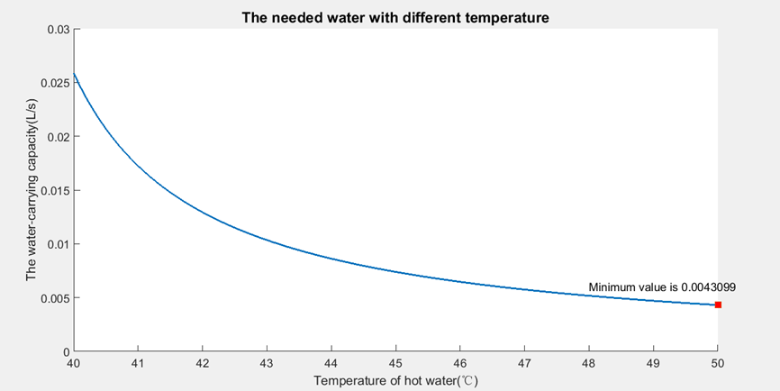

Figure1. The relationship between hot water temperature and water speed

Therefore, the most effective strategy is to heat the water with  hot water and 0.00431(L/s) water speed. In this way, we can save water to maximum extent.

**3.4.4 Result and Analysis**

In a bathtub with the shape of cuboid, we can keep the water temperature close to the initial temperature and reach a dynamic balance by adjusting the hot water temperature and water speed of faucet. The higher temperature the hot water is, the less the water speed is.

### 3.5 Model test

**3.5.1 Precondition**

Base on the analysis in the model 1, we cancel the assumption of dynamic balance, and use the result of model 1, heat the water with  hot water and 0.00431(L/s) water speed. And the initial temperature is still.

**3.5.2 Iteration**

Use the same way as model one, we can calculate and, because of the loss of dynamic balance,

 (3.5.1.1)

What’s more, according to the specific heat capacity formula,



Therefore,

 (3.5.1.2)

Where  means the change of water temperature.

Therefore, the iteration process can be shown as follows,







**3.5.3 Result and Analysis**

Through MATLAB programming, we can know that the water temperature will maintain.

Then we change the initial temperature to do the iteration, using the same strategy, only find that the temperature tend to be ,that is, the temperature will reach after a period of time. The process can be seen in the figure 2.

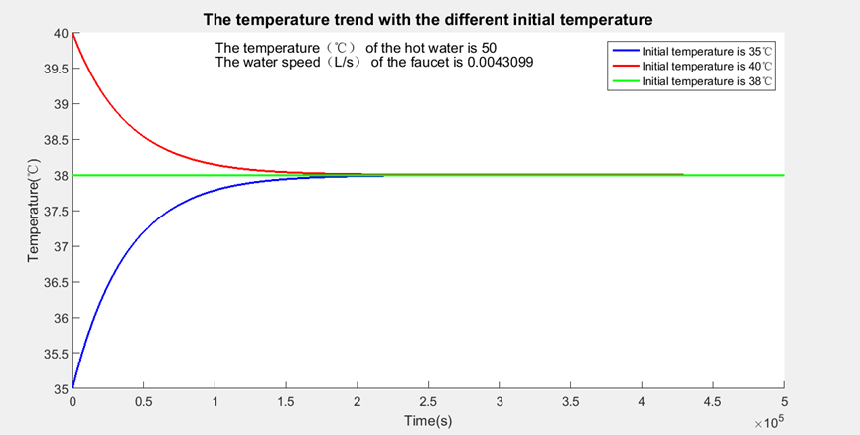

Figure2: The temperature trend with different initial temperature

As Figure 2 clearly shows, even the initial temperature is not 38℃，using the strategy of model one, the temperature will tend to be 38℃，moreover the situation where the initial temperature is 38℃.So this can effectively prove that this strategy can keep the water close to 38℃.

## IV. Model two: Shape selection based on GA

### 4.1 Introduction

In order to determine the best shape of the bathtub to save water and keep the temperature close to the initial temperature, we firstly design several kinds of bathtub patterns according to the bathtub market consumption popularity. Secondly, in this model, our goal is to research the influence of the shape of bathtub to the water temperature inside, so here we do not take the temperature change of hot water into account, that is, the temperature of hot water is set as a constant value. Finally, through Genetic Algorithm, we can gain the size corresponding to the least water speed of the 7 kinds of shapes, then compare the 7 water speed , and choose the shapes and size corresponding to the lowest water speed.

### 4.2 Design the patterns of bathtub

According to bathtub market preference and popularity, we design 7 kinds of bathtub shape. There are:

1. long-style frustum of a prism (lying style)
2. tall-style frustum of a prism (sitting style)
3. frustum of a cone
4. cuboid
5. The combination of cone and frustum of a prism (lying shape)
6. The combination of cone and frustum of a prism (sitting shape)

(7) The combination of half cone and frustum of a prism

Figure 3.1~3.9 show the detailed shapes of bathtub.

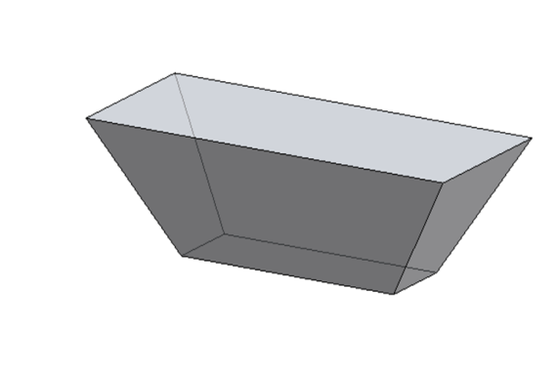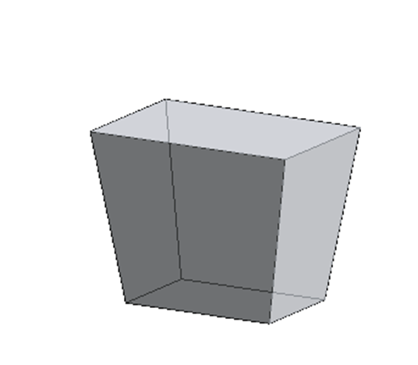

Figure 3.1 Figure 3.2

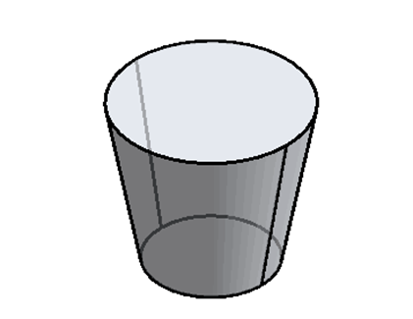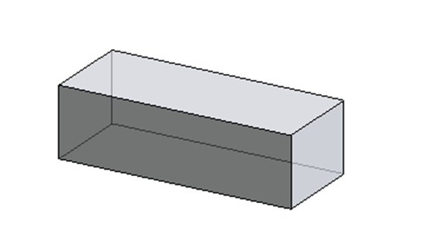

Figure 3.3 Figure 3.4

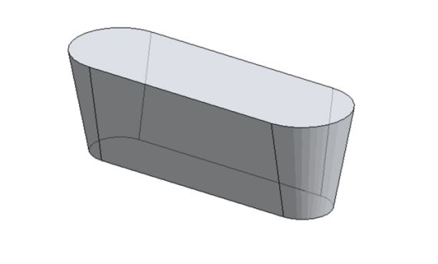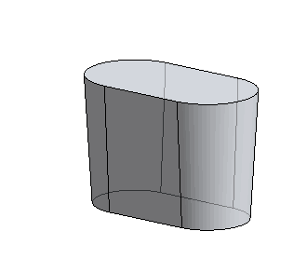

Figure 3.5 Figure 3.6

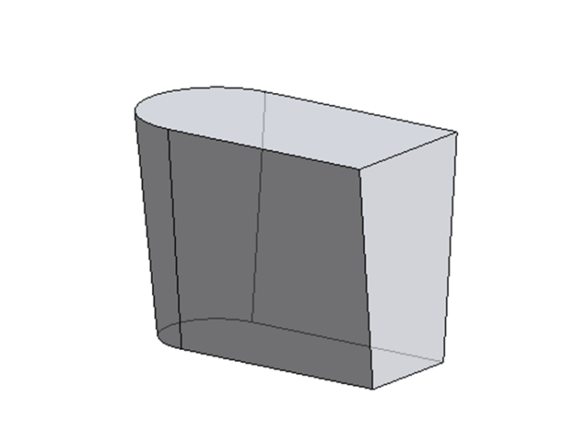

Figure 3.7

In the analysis below, the symbol  is set to represent the sum of lateral area and the bottom surface area, the symbol  is set to represent the upper surface area of the bathtub, and  is set to represent the volume of the bathtub.

All the , ,  can be calculated by using geometry, the detailed calculative process can be seen in the appendix.

And in order to determine the size of bathtub, we give some constraint conditions, the detailed constraint conditions for different shapes can be seen in the appendix.

### 4.3 Determine the best shape of bathtub: Genetic Algorithm

**4.3.1 Introduction**

Genetic algorithm (GA)[4] is one of the self-organizing, adaptive artificial intelligence technologies about mimicking natural biological evolution process and mechanism to solve the extremum problems. It’s also an algorithm that modeling the natural genetic mechanism and biological evolutionism to form a routine search optimal solution. In this model, using Genetic algorithm (GA), we can gain global optimal solution, and avoid to be in the situation of getting local optimal solution, thus the accuracy of model will increase.

**4.3.2 The implementation steps of Genetic algorithm**

Genetic algorithm (GA) is an adaptive and global optimizing probability search method by the binary genetic code. The basic implementation process as follows.

**Step 1:** generate random data

The initial population with the quantity of size M is generated randomly in the interval (L, U). L is the constraint conditions of geometric parameters. The value of U is twice of the geometric parameter constraint conditions.

**Step 2:** Individual fitness evaluation

Put the geometric parameters of all individuals in population variables into model one and calculate the responding water speed which determines the individual's fitness. The lower hot water flow rate is, the higher the fitness is. If the geometric parameters do not meet the constraint conditions, the value of the fitness is 0.01.

**Step3：**Judgment

Determine the relative changes of the fitness value of geometrical parameters. In the first time the value of evolution is 0. When the best population has a long time without evolution, that is, it has 20 consecutive generation without evolution, or the evolution generation has reached 500 or the operation precision reaches a certain level (1 e - 10), we agree that the fitness of the best individual is close to the global optimal one, then end operations, and gain the smallest geometric parameters of v in a constraint condition of the shape of a bathtub. Namely, the shape size of bath crock, otherwise, iterative continue to be performed until meet the judgment conditions.

**Step 4:** Copy

Following the Law of Survival of the Fittest, the percentage of the fitness of each individual accounted for the total fitness, determine the probability of the individual to be copied. So the individuals whose probability is small have a higher probability of being eliminated

**Step 5:** Encode

The geometric parameters which determined the shape of the bathtub are encoded to the binary code. The precision of the geometric parameters keep Four decimal places. The geometric parameters formed binary system, are calculated by the follows.

**Step 6:** Crossover

Crossover operation is crossover operator using a single point or multi-point. Firstly, the random data, which the range is from 0 to 1, is generated one or more crossover point location. If the value of the random number is inferior to 0.8, the number randomly exchanges some of the genetic code in the crossover point location and generates two individuals.

**Step 7:** Mutation

“Basic a mutation operation is used for gene mutations. In order to avoid the later stage of the iteration appear the phenomenon of the premature convergence of the population. The individual species formed the binary genetic code flip for genetic code by mutation rate of 0.2. For example, the number of the binary code changes 0 to 1. Similarly, the number of the binary code changes 1 to 0.

**Step 8:** Decode

The binary variables of geometric parameters back into a decimal, and repeat the step 2.

**4.3.3 Apply Genetic algorithm to determining the shape and size**

**Step 1:**In orderto save water, we decide to heat the water with 50℃hot water, and the self-adaptation function of the problem is



Where v means the hot water speed of the faucet.

**Step 2**: We use different area calculation formula and volume calculation to show the 7 different shapes in this model. The detailed calculation formula for different shapes can be seen in the appendix.

**Step 3**: Combined with the constraint conditions of shape variables, applying Genetic algorithm to 7 kinds of shape, we can gain the 7 sizes corresponding to the lowest water speed 

**Step 4**: Make a comparison in the 7 lowest water speed we gain in Step 2, and choose the lowest one.



Therefore, the best shape and size can be determined.

### 4.4 Result and Analysis

Through MATLAB programming, we can gain the most water-saving sizes of the 7 shapes based on GA. The results can be seen in the table 4.

Table4: The hot water speed of the most water-saving sizes of the 7 shapes

|  |  |
| --- | --- |
| Shapes | The hot water speed corresponding to the most water-saving sizes |
| long-style frustum of a prism (lying style) | 0.003738 |
| tall-style frustum of a prism (sitting style) | 0.002967 |
| frustum of a cone | 0.002837 |
| cuboid | 0.004318 |
| The combination of cone and frustum of a prism (lying shape) | 0.003806 |
| The combination of cone and frustum of a prism (sitting shape) | 0.002728 |
| The combination of half cone and frustum of a prism | 0.002949 |

From the table above, we can gain the result that the most water-saving shape is the combination of cone and frustum of a prism (sitting shape), and the corresponding water speed is 0.002728(L/s). The GA analysis and calculation of most water-saving shapes is shown in figure 4

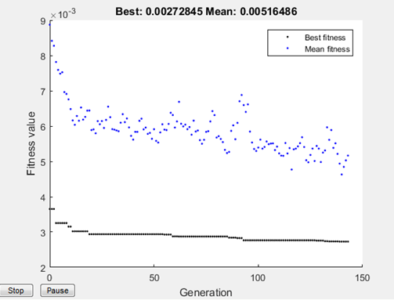

Figure4. The GA analysis and calculation of most water-saving shapes

Table5:The shape parameters of the optimal bathtub

|  |  |
| --- | --- |
| The length of the rectangle in the upper surface | 477 mm |
| The width of the rectangle in the upper surface | 537 mm |
| The width of the rectangle in the bottom surface | 450 mm |
| The height | 703 mm |

The detailed shape and size of the most water-saving one are shown in the figure 5.

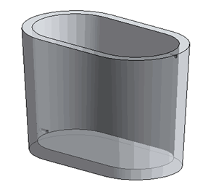

figure5.1

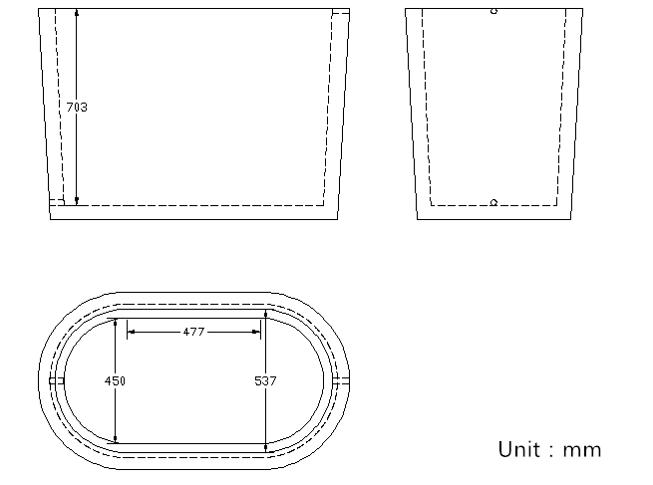

Figure5.2

## V. Sensitivity analysis

### 5.1 Introduction

Sensitivity analysis is a method to research and analyze the change of model output value when system parameters or ambient condition change. Sensitivity analysis in optimization method is often used to research the stability of the optimal solution when original data is not accurate or change. By sensitivity analysis, we can know which parameters play a more important role in the model.

● There are many parameters we use in our model, we choose some prominent to make sensitivity analysis: the shape of bathtub, human factor, heat transfer coefficient, and they can subdivided into some sub-parameters.

The size of bathtub

Human factor

Heat transfer coefficient

Length

Width

Radius

Height weight

movement







Figure 6 parameters system

● In this part, we use the result of model 2, use 50℃ hot water to maintain the temperature of the water in the bathtub., and choose the best water-saving shape we gain in the model 2.

●What we analyze is the change of water speed when the parameters mentioned above. The way we analyze is to change the value of a certain parameters while others don’t change, and observe the change of water speed. In the analysis below, the abscissa is the rate of change of parameters, the ordinate is the value of hot water speed. During the process of sensitivity analysis, we firstly make an overall analysis on all system parameters, then compare the sensitivity of parameters in the same group and find the reason for their sensitivity.

### 5.2 Overall sensitivity analysis on all system parameters

In this part, we analyze how the water speed changes while varying the parameters. The changing processes are shown in the figure 5.

With the analogy to the economics theory, we define elasticity coefficient to measure the effect degree of parameters. The symbol E is set to represent elasticity coefficient.

If E>0, the corresponding parameters have negative correlation with the hot water speed.

If E<0, the corresponding parameters have positive correlation with the hot water speed.

If |E|>1, the corresponding parameters can be seen as remarkable factors.

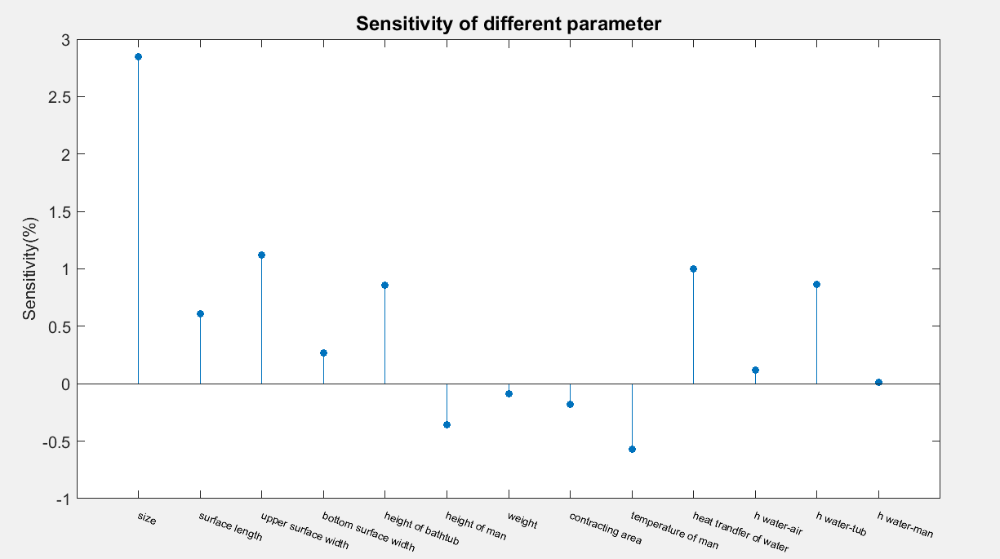

Figure7.Sensitivity analysis of different parameters

**Conclusion:**

As we can see from the figure, the sizes of the bathtub and heat transfer of water are the remarkable factors.

### 5.3 Sensitivity analysis on the shape of bathtub

In this part, we analyze how the water speed changes while varying the size of bathtub. The changing processes are shown in the figure 8.

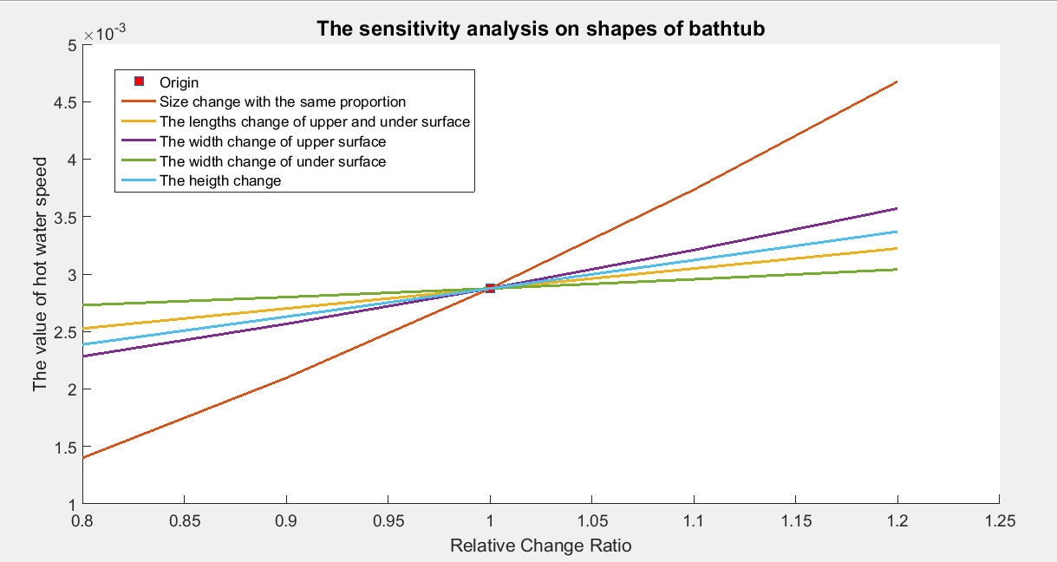

Figure8. Sensitivity analysis on the shape of bathtub

**Conclusion:**

● The size of bathtub plays an important role in the change of water speed.

We can know from model 1 that the heat loss is determined mainly by all kinds of heat transfer contracting area, including the contracting area between water and man, between water and air, between water and the wall of bathtub. Therefore, the influence process of the size of bathtub is shown as followed:

Size

Heat absorption

Heat transfer Contracting area

Heat loss

Water speed

Figure9. Influence process of the size of bathtub

● The influence of the width of upper surface is more prominent than other size parameters.

This is because the value of convective heat transfer coefficient between water and air is the maximum, and through the calculation in model 1, we can know that the main heat-dissipating method is the heat convection between air and water.

What’s more, the influence of the width of upper surface is different from the length of upper surface, the increasing of the width will bring more contracting area between air and water in the same circumstance. So the influence of the width of upper surface is the most important one in size parameters.

### 5.4 Sensitivity analysis on human factor

In this part, we analyze how the water speed changes while human factors change.

The changing process is shown in the figure 10.

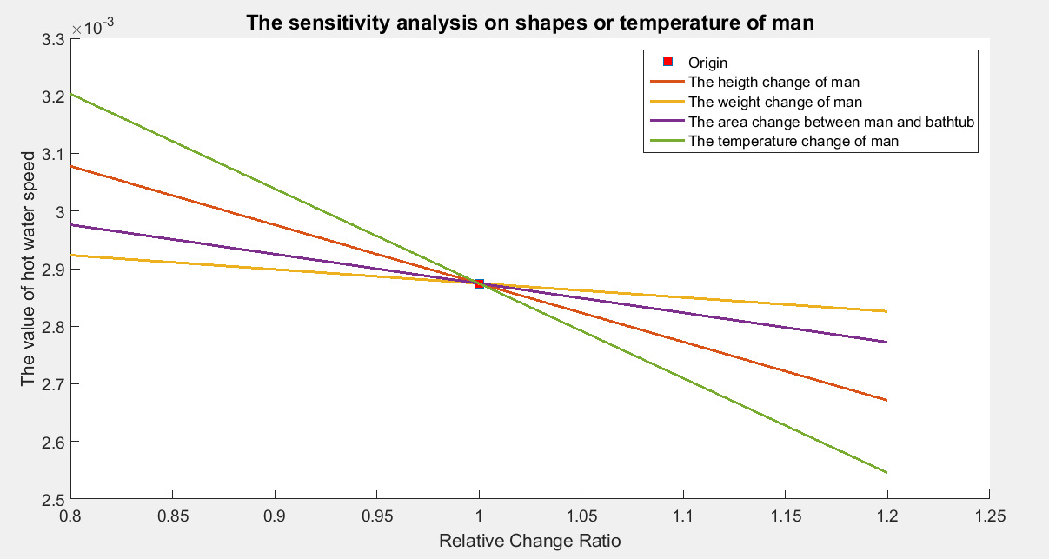

Figure10. Sensitivity analysis on human factors

**Conclusion:**

● The man temperature change has larger influence in the water speed than other human factors.

● The height, weight and contracting area between man and bathtub also influence the water speed, but the influence degree is less than the man temperature.

● The man’s posture can be measured by the contracting area. As we can see from Figure6, the man’s movement is also an important factor in the change of water speed.

When the contracting area between man and bathtub wall increases, the contracting area between water and bathtub wall will decrease. What’s more, the heat transfer between man and water is less than between water and bathtub, so in order to maintain initial temperature, when the contracting area between man and bathtub wall increases, the water speed should be decrease.

### 5.5 Sensitivity analysis on heat transfer coefficient

In this part, we analyze how the water speed change while heat transfer coefficient change. The changing processes are shown in the figure 11.

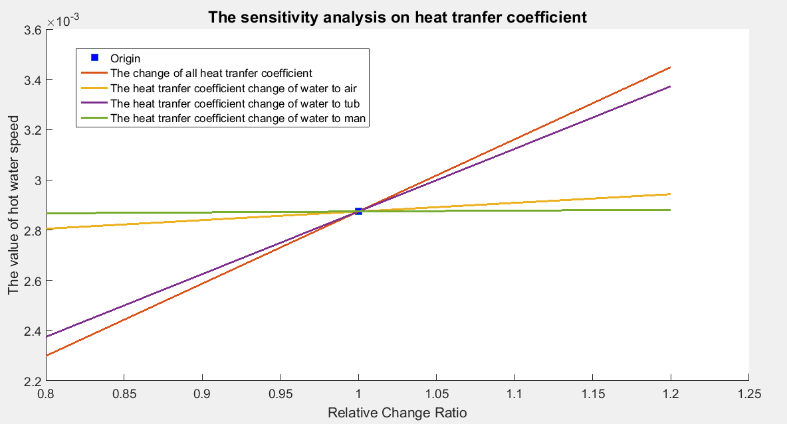

Figure11. Sensitivity analysis on heat transfer coefficient

**Conclusion**:

● The change of various heat transfer coefficient does make large different upon the hot water speed.

● The change of the heat transfer coefficient between water and air, and the change of heat transfer coefficient between water to man makes little influence to the water speed.

● The change of the heat transfer coefficient between water and bathtub wall has large influence upon the hot water speed.

## VI. Bubble does not matter

### 6.1 What the bubble affects

By searching relative information online, what the bubble affect is the convective heat transfer coefficient between air and water. Usually, the bubble will reduce the convective heat transfer coefficient between air and water.

### 6.2 Bubble does not matter

According to the sensitivity

Figure 9 shows the water speed corresponding to different value of convective heat transfer coefficient between air and water.

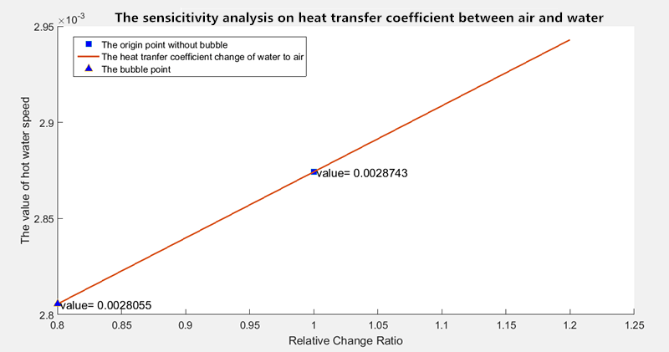

Figure12. Sensitivity analysis on convective heat transfer coefficient between air and water

As we can see from the figure, with the change of the value of convective heat transfer coefficient between air and water, the water speed only change a little(2.39%). Therefore, the bubble matter little.

## VII. Strengths and Weaknesses

### 7.1 Strengths

● Model 1is based on the theory of thermodynamics, so our strategy of keep the temperature even throughout the bathtub and as close as possible to the initial temperature without wasting too much water is objective and efficient.

● In Model 1, we fully consider various kinds of the parameters such as the shape of the bathtub and the human body to solve the problem and the results we get is in perfectly consistency.

● In Model 2, using Genetic algorithm (GA), we can gain global optimal solution, and avoid to be in the situation of getting local optimal solution, thus the accuracy of model will increase.

### 7.2 Weaknesses

● In Model 1, we assume that the movement of the man on the bathtub is intensive enough that when the hot water flows into the bathtub, and ignore the process of the temperature diffusion in the bathtub.

●In Model 1, the irregular shape of the bathtub is not taken into consideration.

●The value of the heat transfer coefficient is related to various factors, and the state value is difficult to calculate.

## VIII. Promotion of the Model

### 8.1 The design of water control device

**8.1.1 Introduction**

From model one and model two, we can know the optimal value of parameters to keep the temperature even throughout the bathtub and as close as possible to the initial temperature without wasting too much water. The parameters include the most water-saving shape of the bathtub, the suitable hot water speed and the temperature of the water in the bathtub. Therefore, we consider whether the difference temperature grade of water in the bathtub is corresponding to the hot water speed under the dynamic equilibrium of the water temperature in the bathtub?

**8.1.2 Implementation steps**

**Step1:** According to the model one and model two, we choose the value of those factors corresponding to the value of the best strategy.

**Step 2:** we set up different aimed tub water temperature, still use 50℃ hot water to heat the water, and use the same solution ways in model 1, we can gain the hot water speed corresponding to different aimed tub water temperature.

**8.1.3 Results and Analysis**

The results are shown as follows.

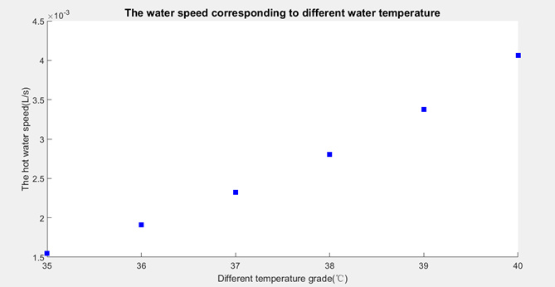

Figure13. The hot water speed corresponding to different aimed temperature

What’s more, we design a convenient and automated device to control the speed of the hot water and the aimed temperature. The device has six levels as follows.

Table6 :The hot water speed corresponding to different aimed temperature

|  |  |  |
| --- | --- | --- |
| level | The aimed temperature (℃) | The hot water speed(L/S) |
| A | 35 | 0.001549 |
| B | 36 | 0.001908 |
| C | 37 | 0.002322 |
| D | 38 | 0.002728 |
| E | 39 | 0.003376 |
| F | 40 | 0.004061 |

### 8.2 The best strategy to fill the empty bathtub

Now, assume that we are going to fill the empty bathtub with 38℃ bath water. As we have discussed in model 1, when the volume of water in the bathtub increases, the heat transfer area will increase, and there will be more heat loss.

The temperature of water in the tub is always lower than 38℃ during the process of filling the bathtub. So the process of 38℃ bath water flowing into the bathtub can be seen as a heating process. Using the same solution as model one, we do a iteration to stimulate the change of water temperature and the volume of water in the bathtub. Through MATLAB programming, we can get the result as figure14 show:

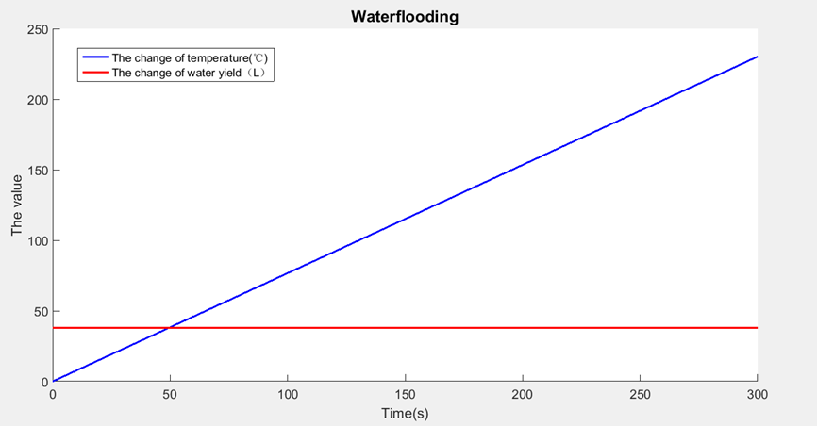

Figure 14: The change of temperature and volume of the water in the bathtub

As we can see from Figure 14, as the volume of water in the bathtub increases, the temperature will change little. So we can conclude that what degree of bath water you want, just setting the temperature of hot water flowing into the bathtub as the temperature you wants.

## IX. The non-technical position paper

Dear users,

It’s our honor to explain some problems about our bathtub for you!

Enjoying in a hot bath is a happy thing while people finish a stressful day of working. Keeping an appropriate temperature of the bathtub water is in favor of relaxing, eliminating fatigue and promoting metabolism. However, it’s difficult to keep an appropriate temperature of the bathtub water evenly, because the bathtub is a simple water containment vessel instead of a spa-style tub with a secondary heating system and circulating jets. Take the common cuboid-sharped tub for example, the heat output reaches to 84000 kJ per minute, which lead to the temperature decrease 1℃ in ten minutes.

Therefore, there are two methods to keep the temperature of the bathtub water evenly. One is installation the electrical heating system to heat the water in the bathtub continuously. The other is to add a constant trickle of hot water from the faucet to reheat the bathing water. However, the former one has the danger of an electric shock and electric leakage. Therefore, the latter one is more suitable. In order to keep the temperature even throughout the bathtub and as close as possible to the initial temperature without wasting too much water, we choose the strategy about designing the bathtub as follows.

**Using acrylic material:** the acrylic bathtub has the advantages about the uniform color, the smooth surface, no delamination or bubble phenomenon. What’s more, the acrylic bathtub has the good insulation effect and its heat conductivity coefficient of the bathtub wall is very low. For example, if the skin contact acrylic bathtub surface does not feel "cold" feeling in the winter.

**Considering the impact of the shape of the bathtub on the process of heat loss:**

We are confident that the chosen bathtub has the excellent thermal insulation after our scientific operations. Our bathtub has the ability to save water.

**The intelligent temperature and speed of water control system:** Our bathtub has five levels to control the speed and temperature of the water depending on your need. At the beginning, the system will automatically fill the empty bathtub with the suitable temperature of the water until the water in the bathtub reach certain amount. Then, the system enter the heat-insulating situation where the water speed decreases and the temperature of the hot water increases. It should be mentioned that you can enjoy the hot bath without worrying at any time.

## X. References

[1] YangZhiijun, some views about the calculation method for burn area, the estimation of the degree of the burn,and the estimation of volume of fluid input during Shock phase[J], Chinese Journal of Medicine,1980.

[2] Yang Shiming,Tao Wenquan.Heat Transfer[M],Higher Education Press, August 2006, Pages7

[3]WeiChunyan, some views about the fundamental principles the heat convection and convective heat transfer[J], private science and technology,July13,2012.

[4] LiuJing,RenZepei,WangCuncheng.The Advancement of bioheat transfore in medicine, Advances in Mechanics，Volume 26, No.2, May 25,1996, Pages 26-31

[5]ZhangXibing,Jinkun,LinMusong. 2D Numerical Simulation for Warm Water Drainage in Tide River Reach,Volume 23,No.3,June,2006.Pages 14-16

[6]ZhuoJinwu,LiBiwen,WeiYongsheng,QinJian.The Application of MATLAB in Mathematical Modeling,Beijing University Press,May,2015.Pages79-100

[7]SiShoukui,SunZhaoliang,Mathematical Modeling Algorithms and Applications,National Defense Industry Press,May,2015.Pages 329-336

[8]XiaoHui,HuaDonghong,LiuWei, the research about the facial size of adult male, Human ergonomics,May1998.

## XI. Appendix

Appendix of Model 2

**1.long-style frustum of a prism (lying style)**

  

Where  means the length of upper surface,  means the width of upper surface,  means the length of bottom surface,  means the width of bottom surface, and *h* means the height of the bathtub.

And in order to determine the size of bathtub, we give some constraint conditions.

s.t.

**2.tall-style frustum of a prism (sitting style)**



 

Where  means the length of upper surface,  means the width of upper surface,  means the length of bottom surface,  means the width of bottom surface, and *h* means the height of the bathtub.

And in order to determine the size of bathtub, we give some constraint condition.

s.t.

**3. frustum of a cone**

  

Where  means the radius of upper surface,  means the radius of bottom surface, and *h* means the height of the bathtub.

And in order to determine the size of bathtub, we give some constraint conditions.

s.t.

**4.cuboid**



Where *l* means the length of the bathtub, *w* means the width of the bathtub, and the *h* means the height of the bathtub.

And in order to determine the size of bathtub, we give some constraint conditions.



1. **The combination of cone and frustum of a prism (lying shape)**



Where h means the height of the bathtub, c means the length of the rectangle in the upper surface, means the width of rectangle in the upper surface, means the width of rectangle in the bottom surface, l means the generatrix of the bathtub.

And in order to determine the size of bathtub, we give some constraint conditions.



1. **The combination of cone and frustum of a prism (sitting shape)**



Where h means the height of the bathtub, c means the length of the rectangle in the upper surface, means the width of rectangle in the upper surface, means the width of rectangle in the bottom surface, l means the generatrix of the bathtub.

And in order to determine the size of bathtub, we give some constraint conditions.



**7. The combination of half cone and frustum of a prism (lying style)**



Where *h* means the height of the bathtub, *L* means the length of the rectangle in the upper surface, *R* means the width of rectangle in the upper surface, *r* means the width of rectangle in the bottom surface, *l* means the generatrix of the bathtub.

And in order to determine the size of bathtub, we give some constraint conditions.



**8.The combination of half cone and frustum of a prism (sitting style)**



Where *h* means the height of the bathtub, *L* means the length of the rectangle in the upper surface, *R* means the width of rectangle in the upper surface, *r* means the width of rectangle in the bottom surface, *l* means the generatrix of the bathtub.

And in order to determine the size of bathtub, we give some constraint conditions.

